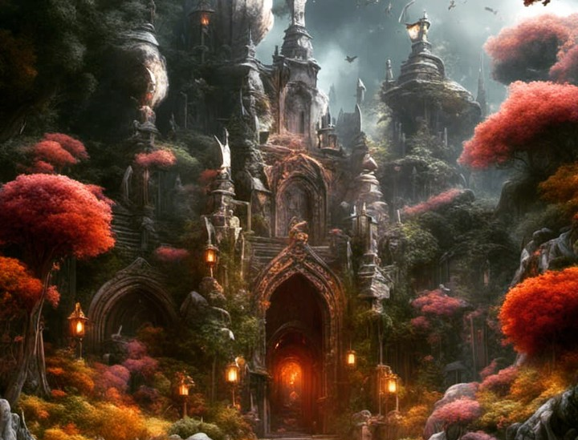
Soul Garden
Game Rule cheat sheet
=======================================================================
Contents
Basic of TTRPG 2
How to playable 2
Dices 2
Soul Garden Rules 3
Abilities and Abilities check 3
Advantages & Disadvantages 3
Critical Success & Failure 3
Skill 3
Masteries 3
Spells 3
Role Play 4
Alignment 4
Themes 4
Profession 4

Basic of TTRPG

How to playable
A role-playing game round typically comprises three stages:
The DM describes the current scene, encompassing settings, events, and NPC actions.
Armed with this information, players make decisions on their course of action.
The DM narrates the character's actions based on the player's choice.
Sessions unfold this way, with players and DM alternating actions and descriptions. In non-combat scenarios, turns aren't strictly necessary, but during fights, structured actions aid clarity. Without a fixed initiative system like D&D or Pathfinder, the DM can establish a turn order at the session's start or use dice rolls when combat arises.
Role-playing hinges on imagination. While DMs can use music, sounds, or visual aids, these are optional. Players might adopt distinct voices or costumes for added immersion, though this is entirely elective and can enhance the experience if chosen.

Dices
Whether you're an experienced TTRPG player or new to the scene, unique dice play a crucial role. Obtain them from stores, online, or employ a digital die roller. These dice are often abbreviated as "d" followed by the face count (e.g., d6 for a six-faced die). For multiple dice, use:
[number of rolls] d [number of faces]
Special dice encompass combinations or unique functions, such as the d100 comprised of two d10s. The first d10 signifies tens, the second units, resulting in numbers from 1 to 100, with 00 representing 100.

Soul Garden Rules

Abilities and Abilities check
In Soul Garden, uncertain outcomes rely on d100 rolls for success or failure. Each character has five ability scores:
- Dexterity: precision, stealth, dodging, and slashing weapons.
- Strength: sheer strength, weightlifting, and blunder weapons.
- Constitution: body-related tasks like taking hits and resisting poison.
- Social: communication, negotiation, and social interactions.
- Instinct: innate sensations and environmental awareness.
- Magic: magic-related actions.
- Intelligence: knowledge, identification, mythology, history, and certain magic manipulation.
Ability scores range from 6 to 95 for adventurers. Steps for ability checks:
- Determine the ability to check (usually the DM's decision).
- Roll d100 for your natural result.
- Adjust for skills or situations.
- If the final result is lower, you succeed.
DM interprets results for outcomes. Lower results yield greater success.

Advantages & Disadvantages
In certain situations, your character's proficiency or efficiency in actions can vary. In such cases, you'll roll twice and select the higher result when at an advantage, and the lower result when at a disadvantage.

Critical Success & Failure
Critical outcomes can occur when natural rolls are extremely low (under 6) or high (above 95). These instances result in significant successes or failures, amplifying the overall impact.

Skill
Skills stem from your character's efforts to acquire knowledge or expertise. They aid ability checks by reducing counts or providing advantages.

Masteries
Masteries resemble classes in Soul Garden. They denote domains your character explores and aims to master, divided into levels:
- Insider: Just beginning
- Adept: Grasping basics
- Confirmed: Mastering basics
- Master: Uncovering core understanding
- Grand Master: Mastering the core
- Avatar: Grasping the Law
- Law: Understanding the Law

Spells
Spells are memorized techniques your character crafted for more controlled use. Derived from masteries, they provide consistent outcomes. While uncertainty remains, your character can attempt actions outside known spells.

Role Play
These rules pertain to your character's description and thought processes. While they don't directly impact the game, they enhance immersion for all players.

Alignment
Alignment reflects your character's behaviour and mindset. On the left, Control aligns with strict rule adherence, as seen in Héméra, Opale's ruler. Intellect values knowledge and logic, like Xavier Madeann, Nephesselaians' creator. Neutral follows life's flow, typified by Phusis and Phusilian. Passionate individuals, like Pagmas, pursue their obsessions fervently. Liberty's free spirits reject restraint, exemplified by the Erebonix society, embracing natural law over rules.


Themes
Passion and theme are 2 to 3 short sentences that will summarize the way your character thinks and what he wants. For Example:
- Only when I fight do I feel alive.
- If he dies, he dies.
- Beer is the most sacred beverage.
A character with those themes will be a battle maniac who doesn’t care if people die, but won’t stand if people mistreat beer.

Profession
In Soul Garden, profession signifies your character's aspirations rather than a class. Classes don't exist. This title reflects their desired or current path.

